**Setting Sprite Position, Rotating and Moving**

https://www.youtube.com/watch?v=LVgYL0_MqXg&list=PLRtjMdoYXLf776y4K432eL_qPw4na_py3&index=16

#include "stdafx.h"

#include "SFML/Graphics.hpp"

#include <iostream>

#include <windows.h>

int main()

{

sf::RenderWindow window (sf::VideoMode(600, 600), "SFML works!");

sf::Texture texture;

sf::Sprite sprite;

texture.loadFromFile("shape.png");

sprite.setTexture(texture);

sprite.setPosition(sf::Vector2f(150, 100));

sprite.setRotation(90);

while (window.isOpen()) {

sf::Event event;

while (window.pollEvent(event)) {

switch (event.type) {

case sf::Event::Closed:

window.close();

break;

}

}

if (sf::Keyboard::isKeyPressed(sf::Keyboard::W)) {

sprite.move(sf::Vector2f(0,-1));

Sleep(5);

}

if (sf::Keyboard::isKeyPressed(sf::Keyboard::S)) {

sprite.move(sf::Vector2f(0,1));

}

if (sf::Keyboard::isKeyPressed(sf::Keyboard::A)) {

sprite.move(sf::Vector2f(-1,0));

}

if (sf::Keyboard::isKeyPressed(sf::Keyboard::D)) {

sprite.move(sf::Vector2f(1,0));

}

if (sf::Keyboard::isKeyPressed(sf::Keyboard::Q)) {

sprite.rotate(-1);

Sleep(5);

}

if (sf::Keyboard::isKeyPressed(sf::Keyboard::E)) {

sprite.rotate(1);

Sleep(5);

}

window.clear();

window.draw(sprite);

window.display();

}

}

**Result (The object can move with keys)**

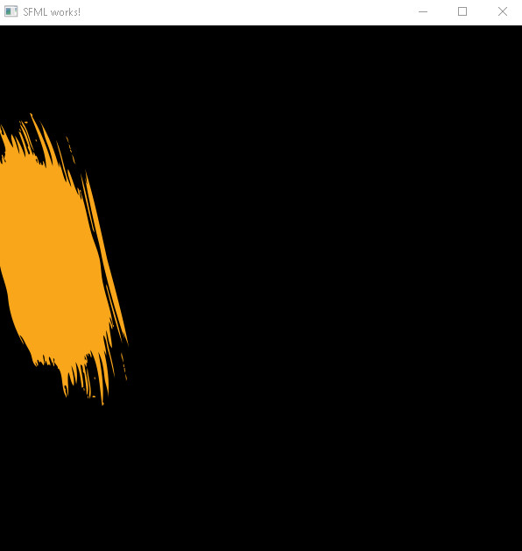

**Important points:**

* sf::Vector2f function stands for Vector 2 float values